Policy Brief: Advancing Green Steel Production through HEPHAESTUS Project

Background
As Europe accelerates its transition toward climate neutrality, the steel industry plays a pivotal role. The HEPHAESTUS project, funded by Horizon Europe, directly supports this transformation by pioneering circular solutions to industrial steelmaking residues. Through cutting-edge innovation, HEPHAESTUS recovers valuable raw materials from electric arc furnace (EAF) dust and other byproducts, aligning with broader EU efforts to decarbonize and modernize steel production.

This brief outlines how HEPHAESTUS complements the shift toward green steel by enhancing material efficiency, supporting renewable energy integration, and reducing dependence on virgin raw materials, while contributing to the EU Green Deal and circular economy objectives.

Executive summary
The European steel industry is undergoing a transformative shift toward sustainability through the adoption of green-steel production methods. Key advances include the replacement of carbon-intensive blast furnaces (BFs) with electric arc furnaces (EAFs), hydrogen-powered technologies, and innovative recycling practices. These initiatives aim to drastically reduce the steel sector's carbon footprint, aligning with the EU’s Green Deal and global climate goals. This document explores current technologies, market drivers, challenges, and future prospects for green-steel production.

Steel production in Europe
The steel industry is a key actor in Europe’s de-carbonization strategy. As such, EAFs are progressively replacing the incumbent BFs, so reducing carbon emissions from steel production by nearly three-quarters. A BF produces 1.8 tonnes of CO₂ per tonne of steel produced, while an EAF only produces 0.6 tonnes of CO₂ per tonne of steel produced. At present, 40% of Europe’s steel is produced with EAFs.

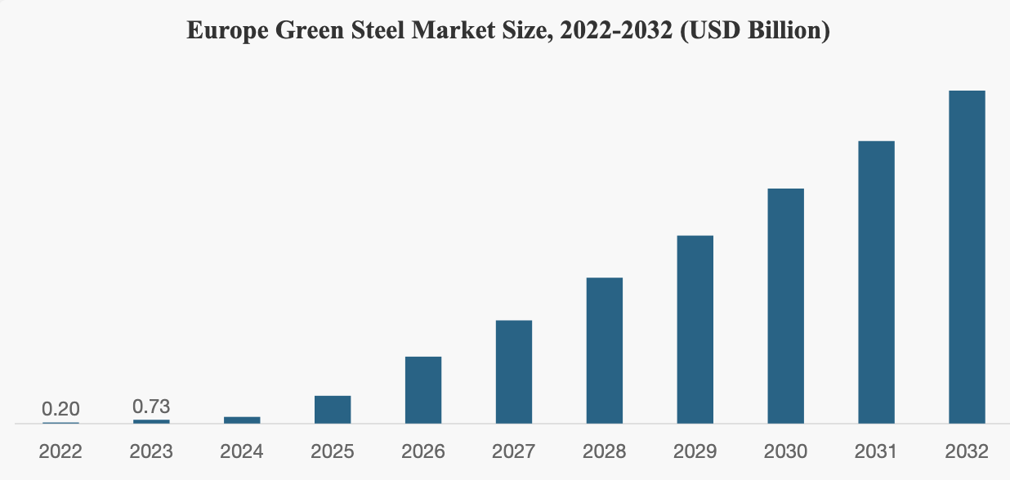
(source www.fortunebusinessinsights.com)

Powering an EAF with renewable electricity would make the process almost 100% carbon-free, reducing these emissions to almost zero. In the future, other technologies, such as hydrogen-powered blast furnaces and molten-oxide electrolysis, will also open new routes for zero-carbon-emission steel. However, renewable electricity is the essential feature making these technologies carbon neutral and environment friendly.

While EAFs represent the future of green steelmaking, their widespread adoption must be accompanied by circular material management. This is where HEPHAESTUS delivers added value.

Pros and cons of the electric-arc furnace and the blast furnace:
Electric-arc furnace | Blast furnace
- Uses obsolescent scrap as the main source of material.  - Uses electricity as its main source of energy to melt scrap and adjust the properties in a ladle furnace.  - Lower initial costs and takes up less space.  - Take less time to manufacture products.  - Has the potential to be practically CO₂ free if the electricity comes from renewable sources. | - Uses iron ore as the source of material and coke as the main fuel and sources of energy.  - Melts iron ore and coke so it can produce pig iron high in carbon content and this is then fed into a converter to remove impurities.  - Needs a high investment in facility development and takes up a large space.  - Easier to produce clean steel.  - Emits a large amount of carbon dioxide.

Green steel in automotive industry
The steel industry is responsible for 7% of global greenhouse gas (GHG) emissions, equivalent to the total GHG emissions of the European Union. The automotive industry is the world’s second-largest user of steel, responsible for about 12% of global steel (17% in the EU, and 26% in the US). The majority of this is high-quality primary steel, rather than recycled steel, which means the automotive sector in an ideal position to drive the green transformation. The International Energy Agency has assessed that the steel sector needs to reduce GHG emissions by 25% by 2030 to be on track for net-zero by 2050. To support this transition the automotive sector needs to commit to green steel for at least a quarter of all steel purchases by 2030. These commitments will come at minimal cost. Switching to 100% green steel would increase vehicle purchase prices by less than 1%.

However, of major producers selling vehicles in Europe, only four have committed to green steel by 2030. The commitments total an estimated 2% of the steel used by these companies.

The steelmakers that supply the automotive sector in Europe produce a large proportion of their steel using BF processes (relative to the steel-market average). The steel produces above-average GHG emissions (> 2 tonnes of CO₂e per tonne of steel). The situation is slightly better in the US, where there is higher share of recycled steel using EAFs, and GHG emissions down to 1.0 tonnes of CO₂e per tonne. Overall, the automotive sector purchases steel with a lower-than-average share of recycled steel.

Recycled steel use in the automotive sector
Recycled steel has limited use in the automotive sector because of the polluting elements that can frequently be found in recycled steel. Some automakers disclose that the recycled content of steel in their vehicles is around 10%–15% (e.g., Volvo Car Group), but this information is only occasionally made public. The automotive-grade steel sheets have around 60% recycled components, i.e., lower than for other applications. The use of recycled steel in cars is thus highly dependent on the quality of the available scrap. There are possibilities to increase the quality of scrap—which would then increase the share of recycled steel in vehicles—but this highlights the need for the improved sorting of metal parts during the dismantling and shredding of end-of-life steel-containing scrap. There are, however, already examples of companies managing to produce automotive-grade steel from 100% scrap (Zong, 2023).

Policy Recommendations
- Promote renewable electricity integration into EAF operations via regulatory incentives and infrastructure investment.
- Incentivize waste valorization and secondary material use, including through green public procurement and critical raw material policies.
- Support industrial-scale demonstration of circular technologies for waste valorization such as those in HEPHAESTUS, to accelerate commercial readiness and deployment.

Conclusion
The path to a sustainable, climate-neutral steel industry must be both low-carbon and circular. The HEPHAESTUS project demonstrates how European innovation can convert industrial waste into strategic assets, reduce emissions, and drive forward the green transformation of one of Europe’s most essential sectors.

Volvo Car Group. (2022). Annual and sustainability report 2022. https://vp272.alertir.com/afw/ f iles/press/volvocar/202303076447-1.pdf
Zong, J. (2023, May 12). China’s road to green steel—Hydrogen metallurgy and iron ore pellets. Fastmarkets. https://www.fastmarkets.com/insights/chinas-road-to-green-steel-hydrogenmetallurgy-and-iron-ore-pellets/

